Vraj Patel

CS 4370

Classwork 3

Activity 1: URL’s:

<http://codd.cs.gsu.edu/~vpatel79/tab_ex1.html>

<http://codd.cs.gsu.edu/~vpatel79/tab_ex2.html>

<http://codd.cs.gsu.edu/~vpatel79/tab_ex3.html>

<http://codd.cs.gsu.edu/~vpatel79/tab_ex4.html>

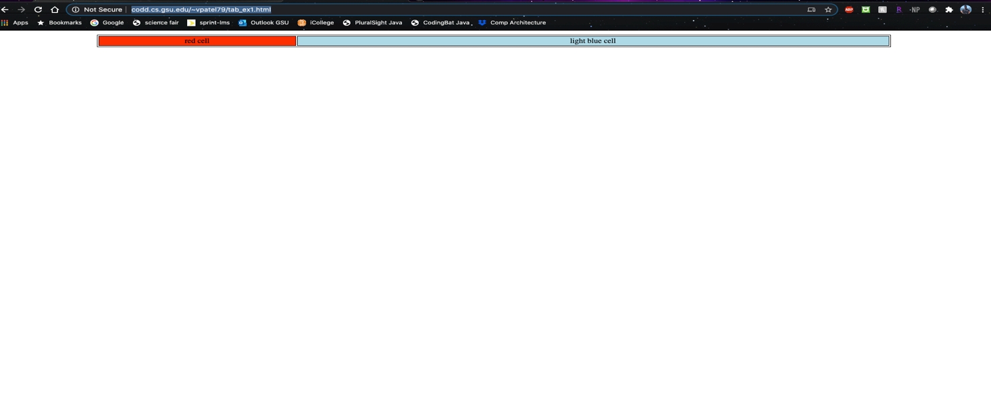

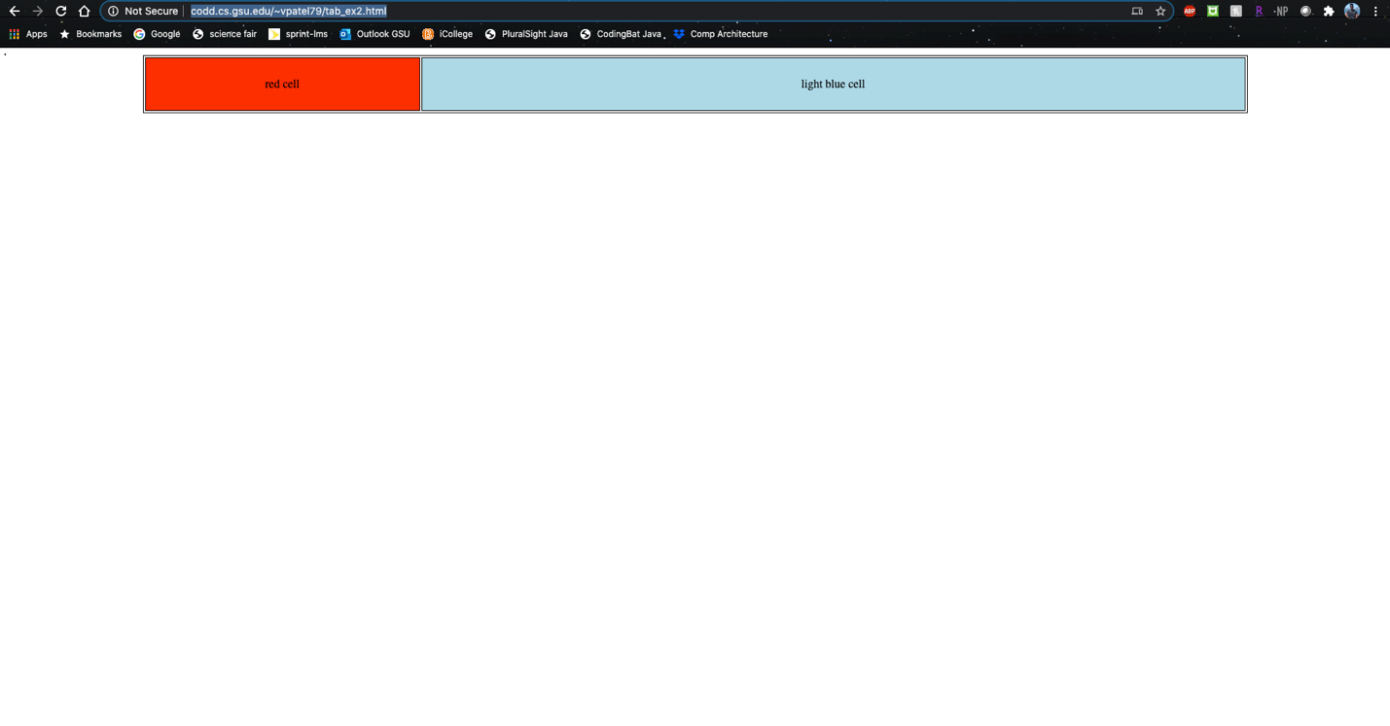

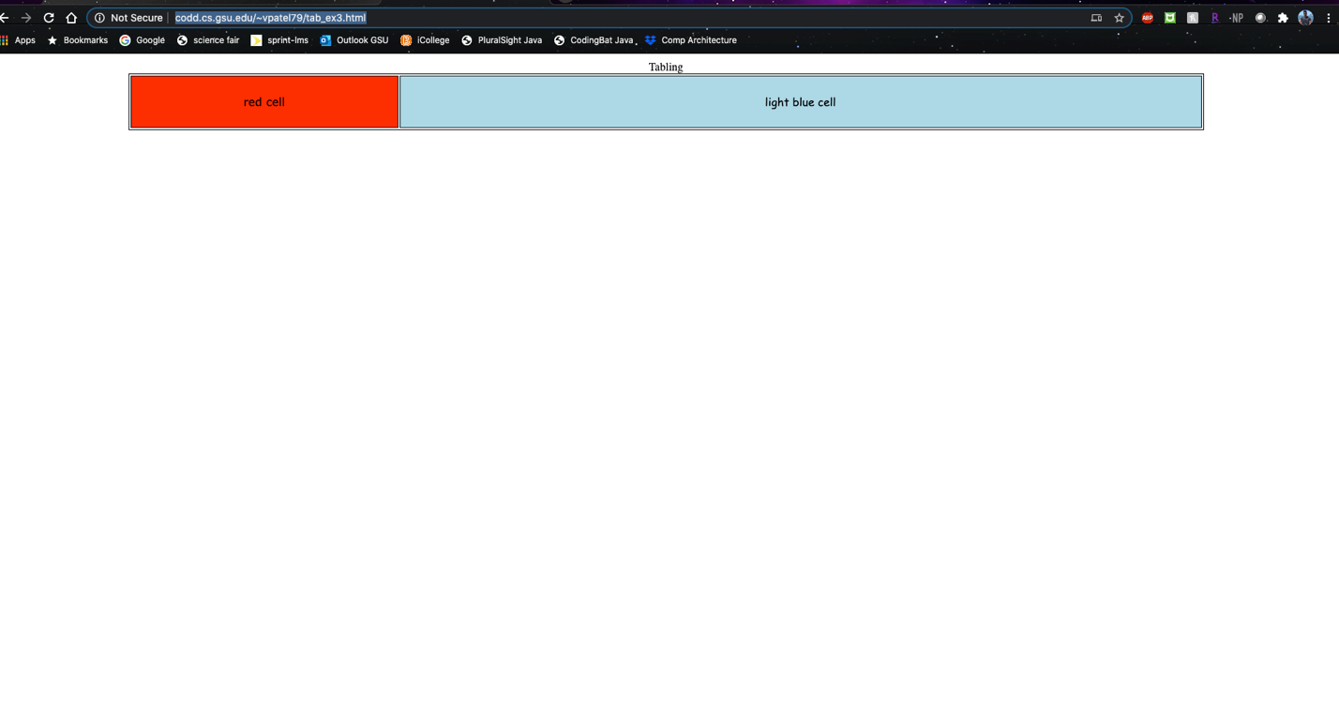

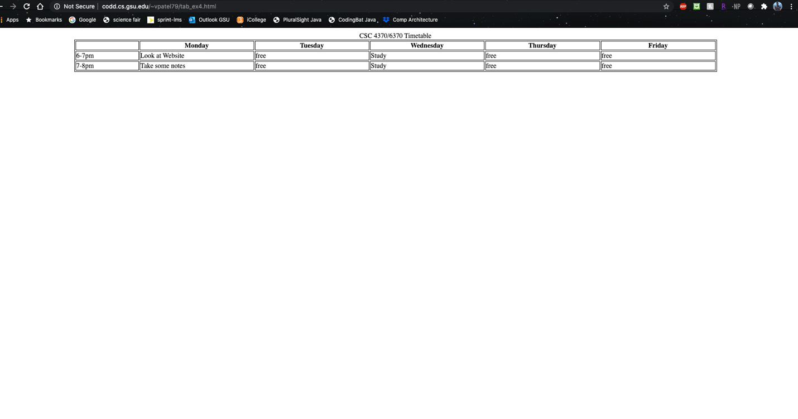

Activity 2: URL

<http://codd.cs.gsu.edu/~vpatel79/act2.html>



Activity 3: URL’s

<http://codd.cs.gsu.edu/~vpatel79/adv_tab1.html>

<http://codd.cs.gsu.edu/~vpatel79/adv_tab2.html>

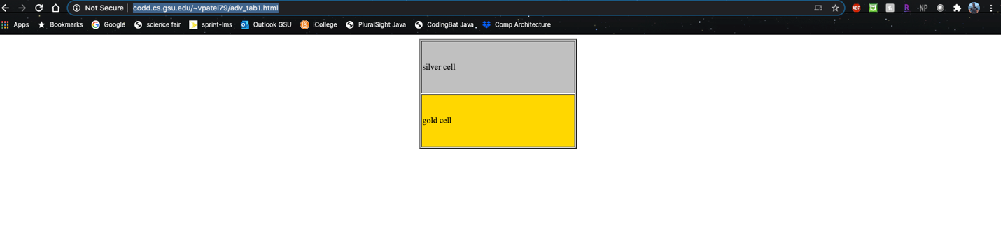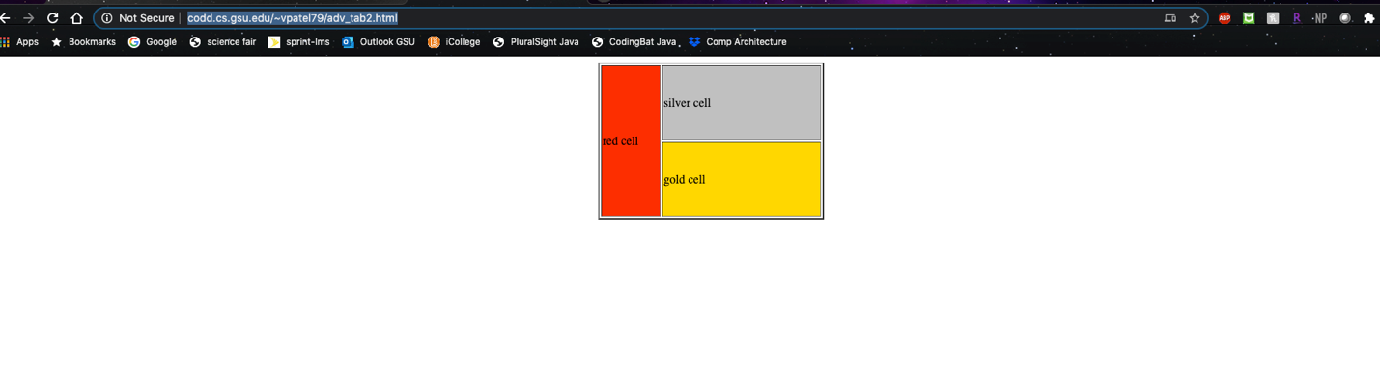

Activity 4: URL’s

<http://codd.cs.gsu.edu/~vpatel79/adv_tab3.html>

<http://codd.cs.gsu.edu/~vpatel79/adv_tab4.html>

<http://codd.cs.gsu.edu/~vpatel79/adv_tab5.html>

<http://codd.cs.gsu.edu/~vpatel79/adv_tab6.html>

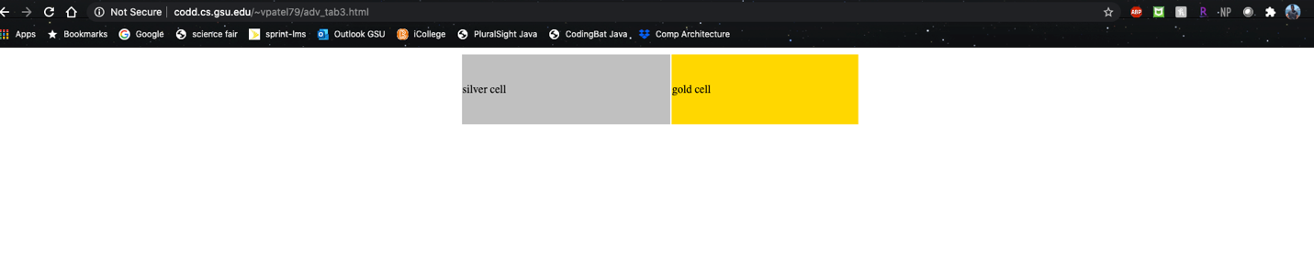

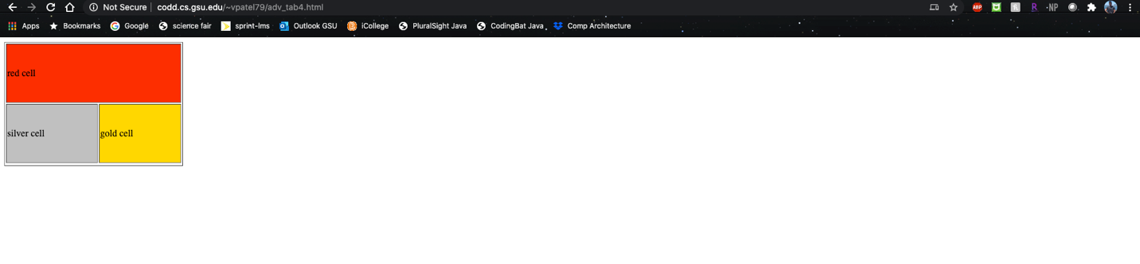

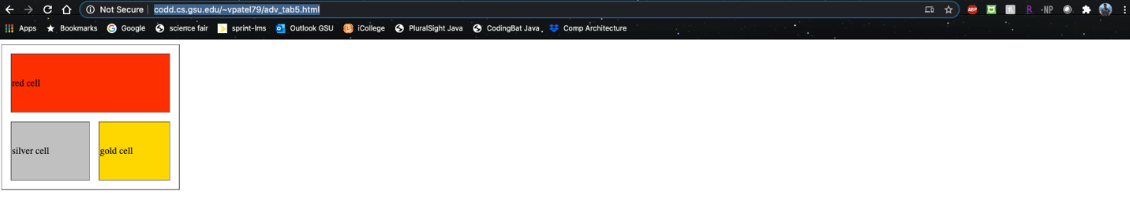

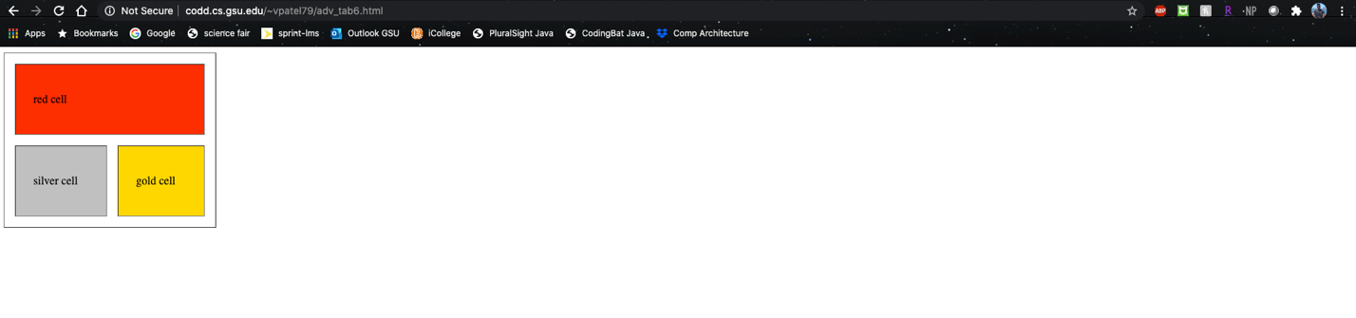

Activity 5 URL’s:

<http://codd.cs.gsu.edu/~vpatel79/adv_tab7.html>



Activity 6 URL:

<http://codd.cs.gsu.edu/~vpatel79/act6.html>

